Assignment #3

Yang Mingyan Doris

1155161584

I am interested in Buffet and Tabehodai (放題) restaurant in Hong Kong. I think there’s no specific website or apps for these restaurants. Although Openrice is an app that provides information about restaurants in Hong Kong, the information is usually provided by users which might not be accurate and most updated. For hotel buffet, information might be provided in hotel’s website which might be difficult for users to compare different restaurant. Also, unlike other restaurant, the cuisine theme of buffet would always change. It is troublesome for user to click on the different hotels’ website for choosing their buffet.

**Interviewees**

1. Master Student - Bian
2. Master Student - Qiu
3. Local Student - Ching
4. Nurse 1
5. Nurse 2

**Persona**

|  |  |
| --- | --- |
| Name: Ching  Age: 23  Sex: Female  Education: University  Marital Status: Single  Industry: Student | Lifestyle: go to school, do assignment, revision, part-time tutorial, gathering with friends, family; social-media user  Dinning preference: School canteen (most of the time), home (most of the time), restaurant (gathering with friends and family)  Media usage preference: social media (Instagram),  Tech product adoption pre: willing to try new technology products  Daily routine: go to school, do assignment, join leisure activities, do sports, gathering with friends and family. |

Most of my interviewees are student, so I choose student for the persona part. Ching is a local student who familiar with Hong Kong internet environment and Hong Kong food culture. She had tried both buffet and Tabehodai in Hong Kong and she is also facing similar problem, such as inadequate restaurant information in Openrice, inconvenient in choosing hotel buffet.

**Journey Map:**

**Problem Statement:**

How might we make a full time university student address the problem of inadequate information about buffet and Tabehodai in Hong Kong to achieve the goal of creating a convenient website for choosing suitable hotel buffet or Tabehodai for her to have a gathering with her friend and family.

**Story Map:**

**Card Sorting:**

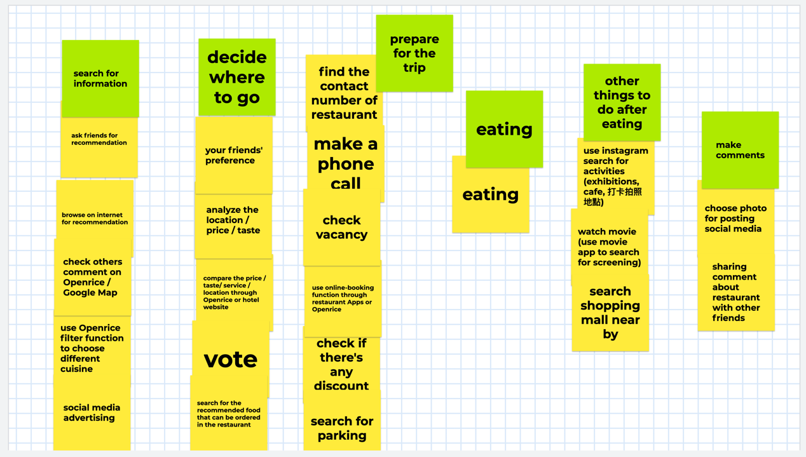

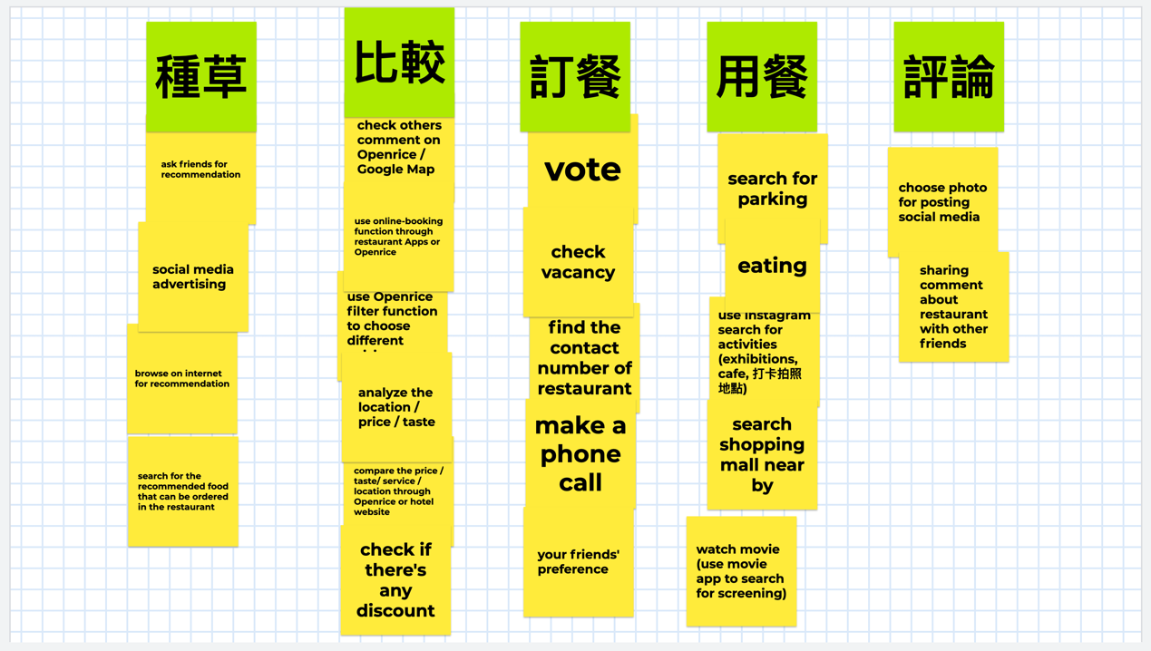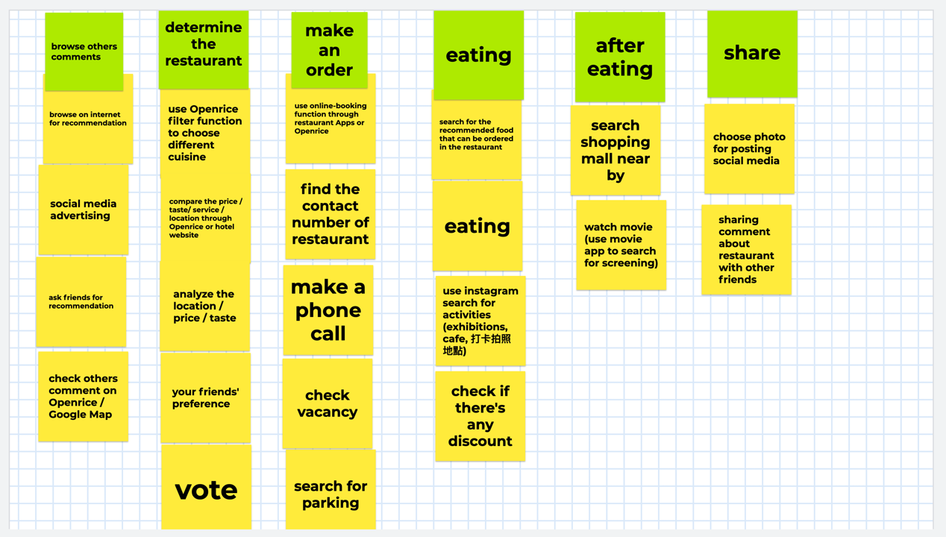

**Positioning Map:**

